NTIA Report 04-413

POTENTIAL INTERFERENCE FROM BROADBAND OVER POWER LINE (BPL) SYSTEMS TO FEDERAL GOVERNMENT RADIOCOMMUNICATIONS AT 1.7 - 80 MHz

Phase 1 Study

VOLUME I
technical report

U.S. DEPARTMENT OF COMMERCE  National Telecommunications and Information Administration

NTIA Report 04-413

POTENTIAL INTERFERENCE FROM BROADBAND OVER POWER LINE (BPL) SYSTEMS TO FEDERAL GOVERNMENT RADIOCOMMUNICATIONS AT 1.7 - 80 MHz

Phase 1 Study
VOLUME I

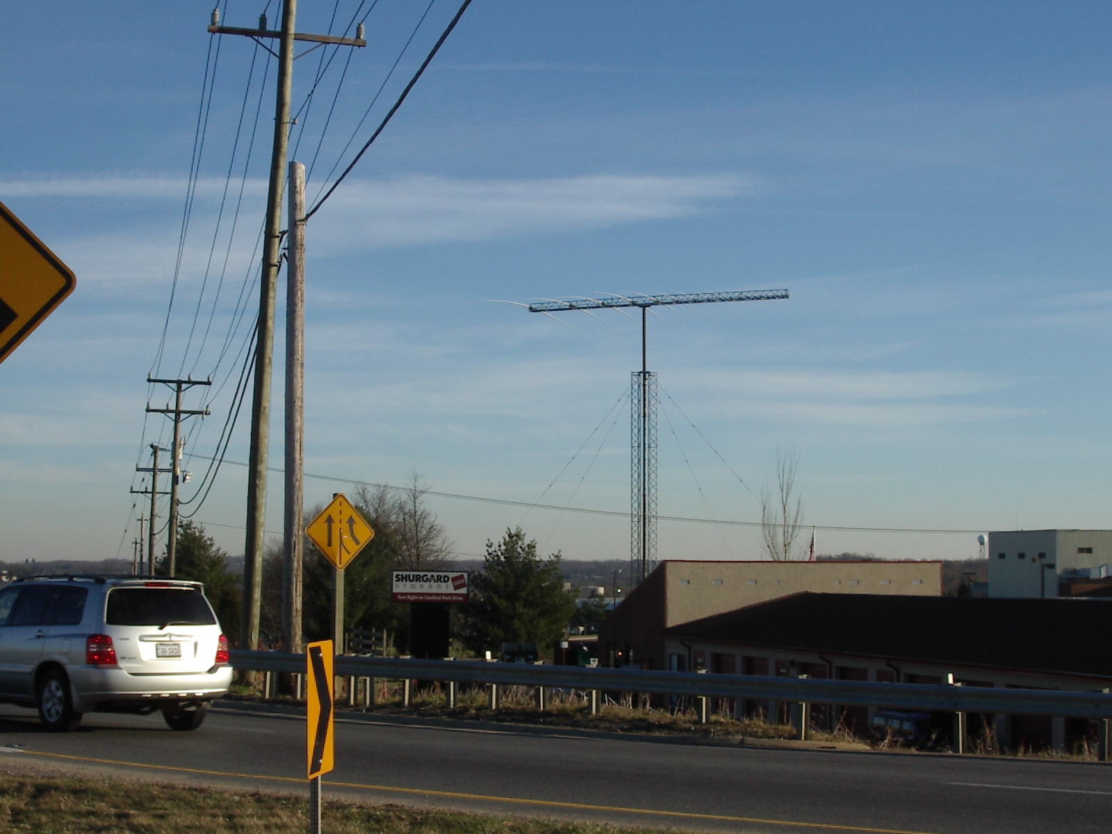

U.S. Department of Commerce
Donald Evans, Secretary
Michael D Gallagher, Acting Assistant Secretary
For Communications and Information

APRIL 2004

