**[3 GHz/7GHz] [Type of Deployment] Deployment**

**Working Paper**

**[September] [XX], 2024**

*[Commentary: Example first page. Feel free to change the text to reflect your views.]*

This paper provides commercial wireless industry input to NTIA as part of the preparation work for the [3 GHz/7GHz] band study planned to begin in the Fall of 2024.

The contributors to this document welcome NTIA’s full use and incorporation of any information deemed helpful in producing NTIA’s input documents to the study process. The main topics addressed in this document include input and feedback on the possible commercial deployment in the [3 GHz/7GHz]band, specifically:

* Commercial network characteristics
* EIRP
* Geography (deployment density)

In summary, we recommend using the data provided.

*[Commentary: Optional Sections to Include]*

Section 1: Commercial Spectrum Needs

Section 2: Commercial Network Characteristics

Section 3: Commercial EIRP

Section 4: Mitigations Towards the Federal Incumbents

(For example:)

* Physical Resource Block (PRB) Blanking
* Antenna Beam Muting
* Antenna Null Steering

Section 5: Geographic Density and Deployment

**Example Data: (This section to be removed when you submit.)**

**Non-Federal Transmitting Modeling**

In the 3.1GHz DoD analysis[1], the 3D radiation model tried to consider the effects that spatial precoding, such as beamforming, have in an aggregate interference evaluation given the increased spatial dependency of emissions in 5G (as compared to previous technologies in 3G and 4G). The foundational component of this modeling are measurements reported in a contribution to the International Telecommunications Union’s (ITU) Active Antenna System (AAS) model from industry,[2] which defines the antenna element and sub-array structure for commercial deployments. 3GPP-standardized MIMO precoding and beamforming codebooks are integrated with an implementation of the ITU’s AAS model to generate representative 3D radiation patterns for use large-scale simulation.

The Monte Carlo simulations aggregate statistics of transmission gains using coarse Synchronization Signal Block (SSB) beams and refined shared channel beams for a specific sector parameterization. These statistics were used to create a 3D radiation pattern. This 3D radiation pattern then serves as the antenna model for the interfering 5G base stations. This process was repeated for specific sector parameterizations to generate unique 3D radiation patterns per parameterization, one for an Urban, Suburban, and Rural deployment.

The figures show the 3D radiation pattern for Urban.

The one additional parameter in the 3.1GHz link budget is: ${DutyCycle}_{dB}$. This is based on the Report on the 38th meeting of ITU-R Working Party 5D, Annex 4.4.[3]

Assuming a TDD Activity Factor: 75%

Assuming a Network Loading Factor: 30%

$$75\%×30\%= 22\%$$

$$10\log_{10}\left(0.2\right)= -6.57 dB$$

$${DutyCycle}_{dB}=6.57dB$$

A 6.57dB reduction (in Base Station EIRP) is applied to each base station. [Not reflected in the figure a below.]

Figure 1: Urban 3D: Radiation Pattern: 50th Percentile

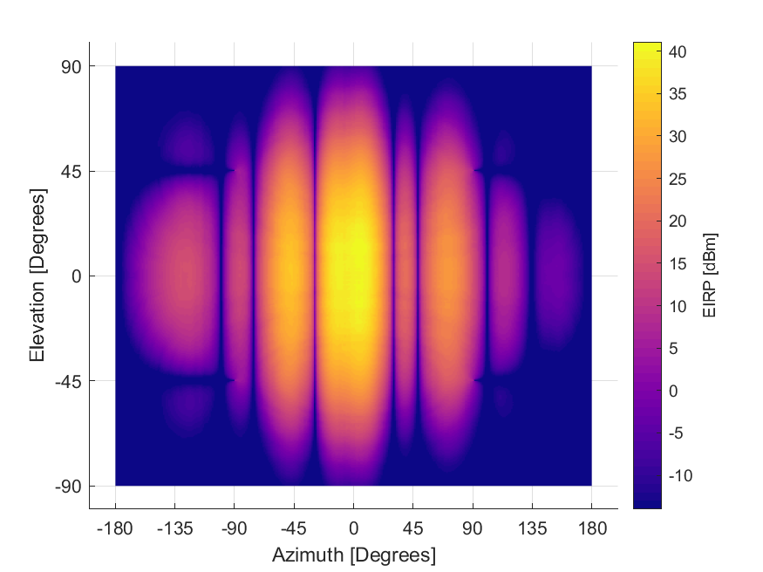

**Format to Submit 3D EIRP Data (In Excel)**

|  |  |  |  |  |  |
| --- | --- | --- | --- | --- | --- |
| Azimuth | Elevation | 10th% | 50th% | 90th% | Max |
| Degree | Degree | EIRP [dBm/MHz] | | | |

Azimuth Degree: -180 ~ 180 [Zero is Main Beam, Clockwise, 90 is right, -90 is left.]

Elevation Degree: -90 ~ 90 [Zero is the Horizon, 90 is up, -90 is down.]

50th Percentile is suggested. Additional percentiles are optional.

EIRP: dBm/1MHz

Example Data:

|  |  |  |  |  |  |
| --- | --- | --- | --- | --- | --- |
| Azimuth | Elevation | 10th | 50th | 90th | Max |
| -180 | -90 | -14 | -14 | -12 | 1 |
| -179 | -90 | -14 | -14 | -12 | 1 |
| -178 | -90 | -14 | -14 | -12 | 1 |
| -177 | -90 | -14 | -14 | -12 | 1 |
| -176 | -90 | -14 | -14 | -12 | 1 |
| -175 | -90 | -14 | -14 | -12 | 1 |
| -174 | -90 | -14 | -14 | -12 | 1 |
| -173 | -90 | -14 | -14 | -12 | 1 |
| -172 | -90 | -14 | -14 | -12 | 1 |
| -171 | -90 | -14 | -14 | -12 | 1 |
| -170 | -90 | -14 | -14 | -12 | 1 |
| -169 | -90 | -14 | -14 | -12 | 1 |
| -168 | -90 | -14 | -14 | -12 | 1 |
| -167 | -90 | -14 | -14 | -12 | 1 |
| -166 | -90 | -14 | -14 | -12 | 1 |

**Example Data: (This section to be removed when you submit.)**

***Non-Federal Transmitter Geography***

For the terrestrial deployment, the Randomized Real deployment from Commerce Spectrum Management Advisory Committee (CSMAC) Working Group 5 Report[4] has been used in the past.

The base station tower locations (≈68k) were based on the Commerce Spectrum Management Advisory Committee (CSMAC) Working Group 5 “Randomized Real”.

*“The randomized real network laydown consisted of a carrier’s actual nationwide base station locations that were shifted random distances up to one mile in random directions.”[5]*

The “Randomized Real” is a set of latitudes and longitudes. Figure 2 shows the locations of the “Randomized Real”.

Figure 2: Randomized Real Locations

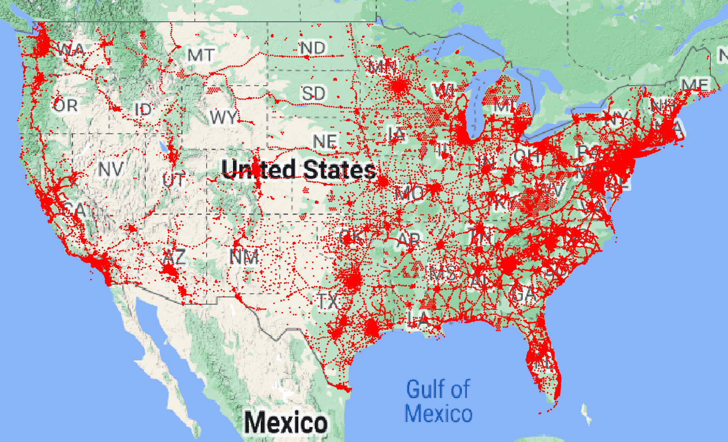

The CSMAC working group concluded that when there is 0dB clutter for base stations, *“Variations in base station antenna heights above ground level had small effects on the predicted required separation distances.” [6]* For this reason, the base station height is assumed to be 30m.

**Format to Submit Geographic Location Data (In Excel)**

|  |  |  |  |
| --- | --- | --- | --- |
| Latitude  [Dec Degree] | Longitude  [Dec Degree] | Antenna Height (AGL)  [meters] | Sector Azimuth  [0 is True North] |
| Degree | Degree |  |  |

Latitude: Decimal Degrees

Longitude: Decimal Degrees

Antenna Height: meters [AGL]

Sector Azimuth: Degrees

(Optional): EIRP Data to Use: (If you have a specific 3D EIRP pattern for each specific location.)

1. <https://dodcio.defense.gov/Portals/0/Documents/Library/DoD-EMBRSS-FeasabilityAssessmentRedacted.pdf>
2. *See* Telefon AB LM Ericsson, Huawei Technologies Sweden AB, Nokia Corporation, “Antenna Pattern Measurements of Sub-6GHz Commercial AAS Base Stations And Antenna Pattern Model For Sharing Studies,” May 31, 2021.
3. <https://www.itu.int/md/R19-WP5D-C-0716/en>
4. <https://ntia.gov/files/ntia/publications/wg5_final_report_posted_03042014.pdf>
5. <https://ntia.gov/files/ntia/publications/wg5_final_report_posted_03042014.pdf>
6. <https://ntia.gov/files/ntia/publications/wg5_final_report_posted_03042014.pdf>