September 25, 2006

Milton Brown
Office of the Chief Counsel
National Telecommunications & Information Administration
1401 Constitution Ave., NW, Room 4713
Washington, DC 20230

Dear Mr. Brown:

Poorman-Douglas Corporation (“PDC”) and Hilsoft Notification (“Hilsoft”) are pleased to submit our joint response to the Notice of Proposed Rulemaking (“NPRM”) issued by NTIA for the “Implementation and Administration of a Coupon Program for Digital-to-Analog Converter Boxes” Docket Number: 060512129-6129-01. PDC and Hilsoft are wholly owned subsidiaries of EPIQ Systems, Inc., a publicly traded company listed on the NASDAQ. EPIQ has been recognized by Forbes Magazine as one of the best small companies in America (2004) and a member of Fortune’s Small Business 100. Combined, PDC and Hilsoft employ 221 employees.

For all correspondence concerning our response to the NPRM our company point of contact will be:

Kelly D. Yaksich, Esq.
Executive Consultant
Poorman-Douglas Corporation
8547 E. Arapahoe Rd., Suite J-573
Greenwood Village, Colorado 80112
303-246-8734
Fax: 303-484-2410
kelly.yaksich@poorman-douglas.com

PDC and Hilsoft appreciate the opportunity to submit our response to the NPRM and we look forward to further discussions as this project develops. If there are any questions about the information we have submitted, do not hesitate to contact me using the information above.

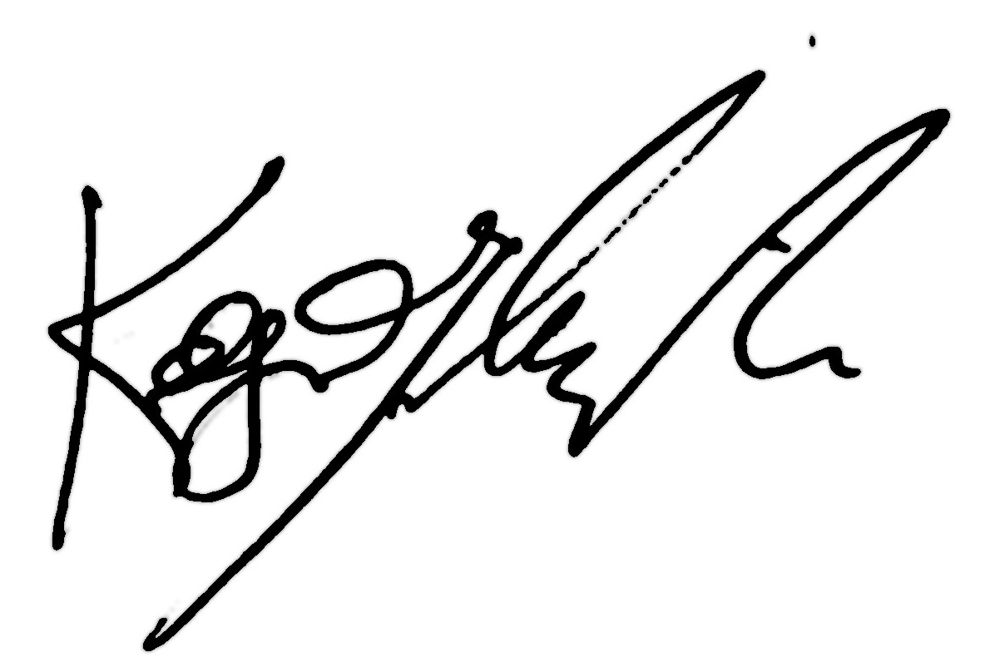
Cordially,

Kelly Yaksich, Esq.
Poorman-Douglas Corporation

A. Program Eligibility

The National Telecommunications & Information Administration (NTIA) should apply a means test to determine households eligible to receive coupons that can be applied toward the purchase of digital-to-analog converter boxes. Means testing is the most responsible way to administer taxpayer resources. As a matter of fundamental fairness, NTIA should make every effort to ensure that only those who need assistance in the purchase of a converter box receive it, with the balance returned to the Digital Television Transition and Public Safety Fund. In addition, means testing will reduce the overall size of the respondent pool and minimize waste, fraud and abuse.

While the cost to process an application requiring proof of eligibility is slightly higher than an application with no restrictions, savings will be realized as the overall number of applications will be much lower and limited to those who truly have an economic need. The possible alternative outcome in a first-come, first-serve model is that the households with the highest need end up applying for the coupon after the funding has been exhausted. With such a diverse population to reach and educate about the program, it will take some time for many segments of the population to hear about it and take action. It would be a disservice to the American public to use the program funds on households that do not demonstrate a need.

One comment proposes to change the eligibility requirements based on response rates during the 15-month program administration. While that type of adaptive system could be implemented, the funds for consumer education are likely not sufficient to support repeated communications to the public about “new” rules contemporaneous with the changing program terms. Establishing means testing will ensure that the fund is sufficient and that coupons are available for those who need economic assistance.

An experienced administrator will be able to cost effectively implement an application process that has means testing as a component of eligibility.

B. Coupon Value and Use Restrictions

A paper coupon, which can have several security features, including unique serial numbers, barcodes, security paper, and consumer identification, supports the controlled disbursements process by requiring the retailer to submit both the coupons and the corresponding merchandise proof-of-sale in order to be paid. The paper format provides for a fast and economical means to mail eligible applicants their coupons in a short time frame. As a practical matter, the program administrator could mail coupons on a daily basis for all applications processed since the prior mailing. This would allow for efficiency in the program and minimize delays in providing program benefits to eligible households. Paper coupons are also straightforward to use. There is no activation required by the recipient and the documents are easily destroyed and recycled at the end of the program to ensure consumer privacy.

A “date certain” expiration date should be printed on the face of each coupon to simplify consumer understanding of the date by which the benefit must be used. With a three-month window of opportunity to use the coupon, the expiration date does not need to be adjusted by an artificial set of criteria such as taking into consideration the number of days it may take the U.S. Postal Service to deliver the item or the exact date a person receives the coupon. Simply calculating the three-month deadline and printing the actual date on the coupon (such as April 19, 2008) will suffice. In the event a person needs his or her coupon reissued, that can be inexpensively accommodated by the program administrator while the total value of all coupons redeemed and coupons issued, but not yet used, is monitored. With unique serial numbers, any expired or “voided” and reissued coupon can easily be tracked in the program administrator’s database with real-time updates to the retailer validation database to ensure no fraudulent attempts to present “lost” or “stale dated” coupons.

C. Consumer Education in Diverse Communities

The Consumer Education program here should include production of messages in varying forms and lengths for use by other stakeholders (i.e., networks, retailers and manufacturers). Other stakeholders will very likely provide some level of contribution to disseminating the Coupon Program message, but it is critical to keep in mind that such contributions are not guaranteed, and the NTIA will have no control over the timing or the message content; stakeholders will likely want to produce their own version of the message, which may or may not emphasize key information or provide all of the information consumers will need to obtain the DTA solution that is best for them. Without assurance of complete and consistent messages, it will not be possible to piece together meaningful calculations regarding the reach of such contributions.

The only way to achieve a Consumer Education program that will provide a guaranteed level of reach among affected households is to include paid media, under a carefully crafted and aggressively negotiated direct-to-consumer advertising plan. The program must focus on reaching those who make up the largest number of over-the-air broadcast viewers and are also the most likely to rely solely on over-the-air broadcasts in analog format (younger, lower income, lower education), with specific outreach to key groups that are smaller but highly likely to be affected (i.e., various minority groups such as Hispanics, American Indians and Alaska Natives). Television will be a key component of the program, but other media and non-traditional methods of dissemination should be considered for minority outreach.

The Internet will be an important component of the program, and can be included inexpensively. The official website, containing all information consumers will need to understand and act, must be designed and written in clear, concise, easily understood language. Its address should be displayed prominently in all notice materials, PSAs, press releases, etc. and stakeholders’ sites should include links to the official website. In order to maximize “top of list” results for the website, keywords should be registered with all major search engines. We would not recommend Internet advertising because those most likely to be affected have lower than average access to the internet, plus the reality that the options of where to advertise are too vast to achieve an effective campaign; the available funds must be used judiciously, in efforts that will garner the most effective reach and efficiencies.

Hilsoft Notifications specializes in designing and implementing media-based notice campaigns that reach large percentages of affected consumers, regardless of the target audience size and profile—including substantial portions of the U.S. population coupled with an emphasis on particular segments, as is the case here—and we have accomplished all such notice programs for less than $5 million. Two relevant examples are outlined below.

U.S. Department of Agriculture - Tobacco Transition Payment Program

When the Jobs Creation Act of 2005 required a massive transition to the free market from the tobacco “quota” system, Hilsoft Notifications was called by the U.S. Department of Agriculture to design and implement a multi-stage notice program informing tobacco farmers and quota holders of the USDA’s $10 billion tobacco growers’ transition payment program. Hilsoft’s expert media planners studied the target audience and analyzed the coverage of media vehicles in the 500+ targeted counties, in 17 states. Like here, the majority of affected people were not minorities, but minorities were a distinct and critical portion of the target audience. The resulting media plan utilized geographically and demographically targeted media, including television, daily newspapers, community newspapers, minority publications, agri radio, and minority radio. Hilsoft designed multi-media Notices using clear, concise, plain language, with attention-getting graphics and, for broadcast, culturally appropriate and commanding voices. Notices for Hispanic media were translated and produced in Spanish. The campaign included a “reminder” notice, alerting affected people of the upcoming sign-up deadline. Upon completion of the campaign, Hilsoft Notifications prepared detailed analyses of each of the various media efforts undertaken. The analyses illustrated the comprehensive coverage of the campaign and target audience, as well as the thousands of additional media placements that were negotiated and appeared free of charge.

Residential Schools Settlement

The Canadian government turned to Hilsoft Notifications to design and oversee the largest and most complex settlement in Canadian history when in 2005 it faced the need to resolve aboriginal claims of abuse stemming from century-old treatment in the “residential school” system. Working to figure out how to locate, reach and inform Indian, Métis, and Inuit (Eskimo) populations throughout Canada, including in the most remote parts of the country, Hilsoft undertook a multi-prong, culturally-appropriate notification effort, which included marshaling and coordinating the concurrent efforts of multiple different stakeholders in the litigation, including the government, churches and lawyers for residential schools Survivors. The notice program was complicated by target audience profiles that determined that communicating with Survivors would be difficult, owing to age, education and language barriers and ultimately Hilsoft produced graphically appropriate materials in 20 different aboriginal languages, plus English and French.

It will be critical for the NTIA to be able to say that a well-planned, effective effort to reach over-the-air television viewers was achieved, especially to those consumers who are most likely to be affected. Such a program needs to be done, and can be done.

D. Minimizing Waste, Fraud and Abuse

The converter box program is a sizeable and complex undertaking, requiring experience and technical resources in a variety of areas to implement effectively. To keep the various stages of the program connected and in synch, the program should have an end-to-end solution provider. From consumer education to the application process through coupon redemption and final reporting, the program administrator will need to track, manage, and report key metrics. Attempting to manage meaningful statistics across various entities involved in program administration would be very difficult and costly. Furthermore, with a salient portion of the administration involving consumer and public communication, having multiple entities managing pieces of the program could prove frustrating to those the program is intended to serve. In order for the customer service portion of the program to be successful, the program administrator needs to be able to provide both general information about the program rules (for example, how the program works, the eligibility criteria to participate, the deadlines to apply, or a request for an application) and specific information to the person requesting assistance (for example, the status of an application, the retailer availability to use a coupon, the means by which to replace a lost coupon, or help in connecting a converter box).

The most cost effective method to implement a program of this size is to have the major components handled by a single-source provider, including consumer education, application dissemination, informational website, toll-free phone support, application review, eligibility determinations, coupon mailings, coupon redemption tracking, retailer coordination, comprehensive reporting, and program stewardship.

