November 16, 2006

Poorman-Douglas Corporation
10300 SW Allen Blvd.
Beaverton, OR 97005

Mr. Milton Brown
Deputy Chief Counsel
Office of the Chief Counsel
National Telecommunications and Information Administration
U.S. Department of Commerce
1401 Constitution Ave., NW
Washington, DC 20230

Dear Mr. Brown:

The following is a summary of our meeting on November 14, 2006 where we discussed our comments submitted in response to the Notice of Proposed Rulemaking (NPRM) published by the NTIA on July 25, 2006 (71 Fed. Reg. 42,067) regarding the implementation of a digital-to-analog converter box coupon program.

Means Testing
Poorman-Douglas supports the application of a means test to determine household eligibility for participation in the coupon program. A means test is the most responsible method to administer limited taxpayer resources. While the cost to process applications requiring proof of eligibility is slightly higher than an application with no restrictions, savings will be realized as the overall number of applications will be reduced.

Coupon Value and Use Restrictions
A paper coupon provides for a fast and economical means to mail eligible applicants their coupons in a short time frame while also incorporating several security features, including serial numbers, barcodes and security paper that will reduce the instances of waste, fraud, and abuse.

Consumer Education
While it is crucial to the success of the program that key stakeholders contribute to the consumer education component of the initiative, it is important to remember that such contributions are not guaranteed, and the NTIA may not have total control over the timing or the message content. The consumer education program should include the production of messages in varying forms and lengths for use by other stakeholders (i.e., networks, retailers and manufacturers). Consumer education campaigns must not be one-size-fits-all but should take into account rural populations, Native Americans, non-English speaking communities, and elderly citizens.

Accountability & Tracking
Poorman-Douglas has the ability to provide real-time coupon tracking and redemption updates in a secure password-protected environment.

Partnerships
Poorman-Douglas encourages the NTIA to publish the list of all entities having submitted comments in response to the Request For Information (RFI) published on July 31, 2006 to help facilitate cooperation and collaboration among various providers.

Please feel free to contact me at (303) 246-8734 if you have any questions.

Sincerely,
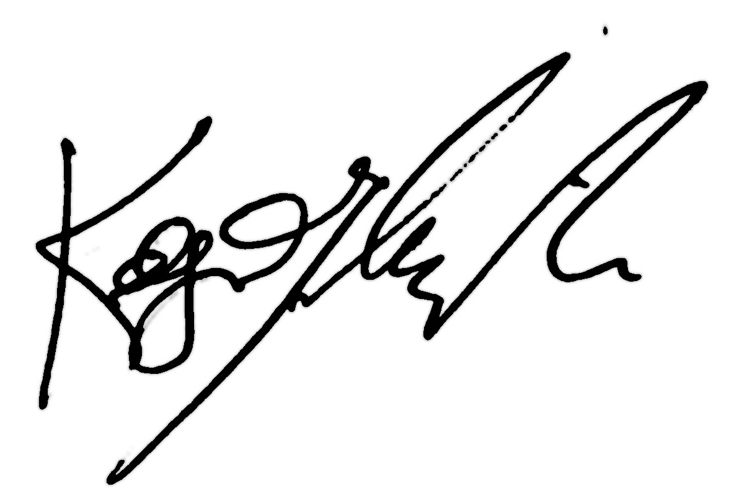

Kelly D. Yaksich, Esq.
Poorman-Douglas Corporation

